GO NATIVE TREE
By: Sheila Haynes

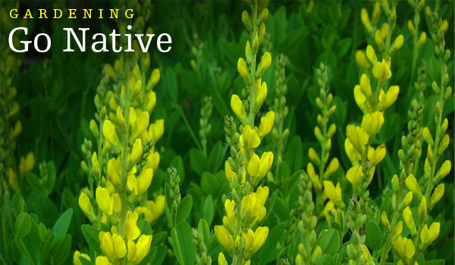

Fair Market Value: $775.00

Includes:

- Pineapple Bag by Hurricane LTD
- Collection of 4 Trucker Hats by Sea Sea Hawaii
- Iwa Bird Print (8x8) by Artist Abby Romanchak
- Iiwi Bird on Lehua Ohia by Artist Nanea Haynes
- Hookipa Pineapple/Aloha Pillow with insert (12”x18”) designed on Maui by Maka Sea
- Aloha Bracelet by Artist/Jeweler Sandi Stoner

